**API Documentation on mini jiji ecommerce website**

**Base URL**

⇨ [http://localhost:1000/api/product](http://localhost:1000/api/products)s

Link to Live website:

* https://mini-jiji-clone.onrender.com/

**Endpoints**

1. Get All Products

**Endpoint**:

* + GET /products

**Description**:

Fetch all products, optionally filtered by category, region, price range, etc.

Request Parameters:

* + category (optional): Category ID to filter products by category.
  + region (optional): Region ID to filter products by region.
  + minPrice (optional): Minimum price to filter products.
  + maxPrice (optional): Maximum price to filter products.

Response: 200 OK: Returns a list of products.

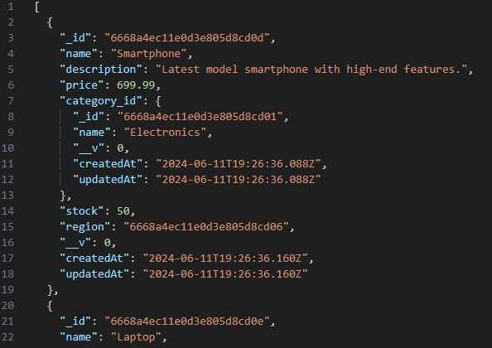

1. **Get Product Details**

**Endpoint:**

* + GET /products/:id

**Description:** Fetch detailed information for a specific product.

**Request Parameters:**

* id: The ID of the product.

**Response:**

* **200 OK**: Returns the details of the specified product

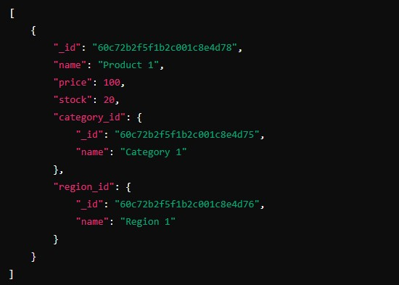

**404 Not Found**: Product not found.

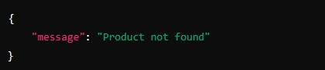

**3. Add Product to Cart Endpoint:**

⇨ POST /cart

**Description:** Add a product to the cart. If the product is already in the cart, increment its quantity.

**Request Body:**



**Response:**

• **201 Created**: Product added to cart successfully

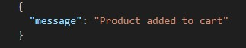

**400 Bad Request**: Not enough stock available.

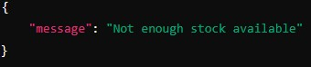

**404 Not Found**: Product not found

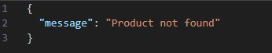

1. **Get Cart Items Endpoint:**

⇨ GET /cart

Fetch all items in the cart.

**Response:**

* + **200 OK**: Returns a list of cart items

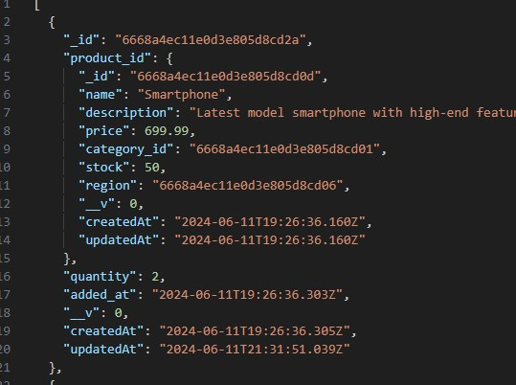

1. **Update Cart Item Quantity Endpoint:**

⇨ PUT /cart/:id

**Description:** Update the quantity of a specific item in the cart.

**Request Body:**

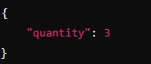

**Response:**

* + **200 OK**: Cart item quantity updated successfully

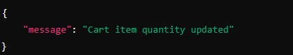

**400 Bad Request**: Not enough stock available or invalid quantity.

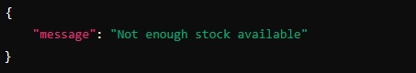

**404 Not Found**: Cart item not found

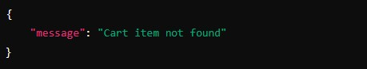

**6. Delete Cart Item Endpoint:**

⇨ DELETE /cart/:id

**Description:** Delete a specific item from the cart.

**Response:**

• **200 OK**: Cart item deleted successfully

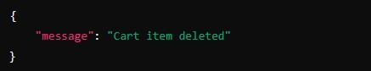

**404 Not Found**: Cart item not found

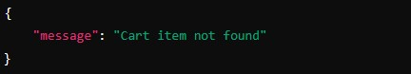

**Notes**

* Ensure that appropriate headers such as Content-Type: application/json are set for the requests.
* All endpoints expect the data in JSON format for both request bodies and responses.

**Example Usage**

**Fetch All Products with Filters**

⇨ GET

/products?category=60c72b2f5f1b2c001c8e4d75&region=60c72b2f5f1b2c001c8e4d76& minPrice=50&maxPrice=200

**Add Product to Cart**

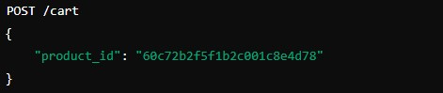

Update Cart Item Quantity

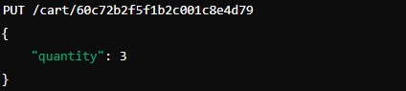

Delete Cart Item

